Name : Alveena Naz

Registration Number : FA25-BSE-010

PFLab Tsk 4:

Activity 1:

import java.util.Scanner;

public class FirstJava
{
public static void main(String[] args)
{
Scanner input = new Scanner(System.in);
System.out.println(" Enter a year:");
int year = input.nextInt();
boolean isLeapYear = (year % 4 == 0 && year % 100 != 0) || ( year % 400 == 0);
System.out.println( year +" is a Leap Year? " + isLeapYear );

}

}
OUTPUT:
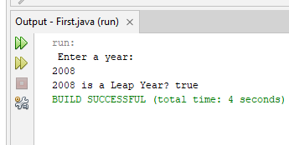
Activity 2:
import java.util.Scanner;

public class FirstJava
{
public static void main(String[] args)
{
Scanner input = new Scanner(System.in);
System.out.println(" Enter an integer number:");
int number = input.nextInt();
if( number % 5 == 0)
System.out.println(" HiFive");
if( number % 2 == 0)
System.out.println(" HiEven");

}

}
OUTPUT:
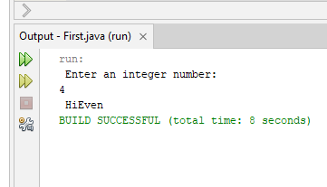

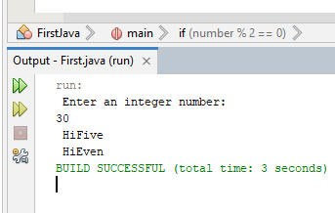

Activity 3:
import java.util.Scanner;

public class FirstJava
{
public static void main(String[] args)
{
Scanner input = new Scanner(System.in);
System.out.println(" Enter worked hours:");
int hoursWorked = input.nextInt();
System.out.println(" Enter the pay rate:");
double payRate = input.nextInt();
double wages;
double overTime;
if( hoursWorked > 40)
{
wages = 40 * payRate + (hoursWorked - 40 ) * payRate * 1.5;
System.out.println(" The wages are :" + wages);
}
else
{
wages = hoursWorked * payRate;
System.out.println(" The wages are :" + wages);
}

}

}
OUTOUT:
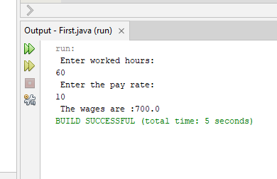

Activity 4:
import java.util.Scanner;

public class FirstJava
{
public static void main(String[] args)
{
Scanner input = new Scanner(System.in);
System.out.println(" Enter Score:");
int score = input.nextInt();
if(score >= 90)
System.out.println(" The grade is A");
else if( score >=80)
System.out.println(" The grade is B");
else if(score >= 70)
System.out.println(" The grade is C");
else if( score>= 60)
System.out.println(" The grade is D");
else
System.out.println(" The grade is F”);

}

}

OUTPUT:
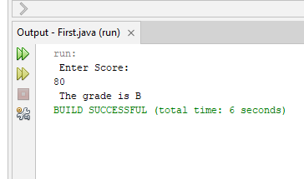

Activity 5;
import java.util.Scanner;

public class FirstJava
{
public static void main(String[] args)
{
Scanner input = new Scanner(System.in);
System.out.println(" Enter 1 2 or 3:");
int number = input.nextInt();
switch( number)
{
case 1: System.out.println("you entered 1 ");
break;
case 2: System.out.println("you entered 2 ");
break;
case 3: System.out.println("you entered 3 ");
break;
default: System.out.println("Invalid number ");

}

}

}
OUTPUT:
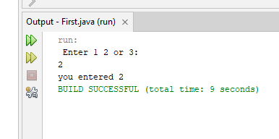

Graded lab task 1:

public class FirstJava
{
public static void main(String[] args)
{
int x = 10, y = 15, z = 20;
boolean exp1 = ( !( x> 10));
System.out.println(" The 1st expression is " + exp1);
boolean exp2 = ( (x <= 5) || y < 15);
System.out.println(" The 2nd expression is " + exp2);
boolean exp3 = ( ( x!=5) && (y!=z));
System.out.println(" The 3rd expression is " + exp3);
boolean exp4 = ( ( x>=z) || (x + y >=z));
System.out.println(" The 4th expression is " + exp4);
boolean exp5 = ( ( x<= y - 2) && (y>= z) || (z - 2 != 20));
System.out.println(" The 5th expression is " + exp5);

}

}

OUTPUT:
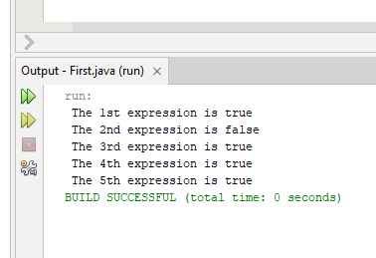

Graded lab task 2;

public class FirstJava
{
public static void main(String[] args)
{
int x = 3, y = 4, z = 7 , w = 1;
System.out.println("x == y: " + (x == y ));
System.out.println("x != z: " + (x != z ));
System.out.println(" y == z - 3 " + ( y == z - 3));
System.out.println("!(z > w): " + ! (z > w));
System.out.println("x + y < z: " + (x + y < z));

}

}

OUTPUT:
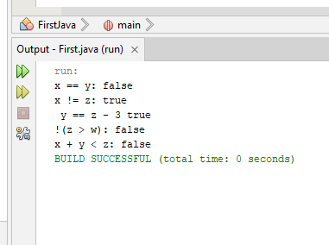

Graded lab task 3:

public class FirstJava
{
public static void main(String[] args)
{
boolean b1=true;
boolean b2=false;
boolean b3=(b1==b2);
System.out.println(" The value of b3 is " + b3);

}

}
OUTPUT:
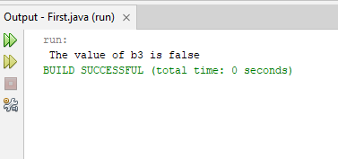

Graded lab task 4:

Part a:

public class FirstJava
{
public static void main(String[] args)
{
int a = 5;
int b = 6;
int minValue = Math.min(a, b);
System.out.println(" The minimum number is :" + minValue);

}

}
OUTPUT:
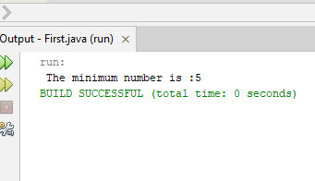

Part b:

public class FirstJava
{
public static void main(String[] args)
{
int a = 5;
int b = 6;
int maxValue = Math.max(a, b);
System.out.println(" The maximum number is :" + maxValue);

}

}
OUTPUT:
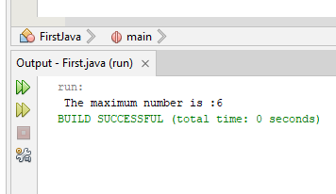

Part c:

import java.util.Scanner;
public class FirstJava
{
public static void main(String[] args)
{
Scanner input = new Scanner(System.in);
System.out.println(" enter an integer number ");
int number = input.nextInt();
if ( number > 0)
System.out.println(" 1 ");
else if( number == 0)
System.out.println(" 0 ");
else
System.out.println(" -1 ");

}

}
OUTPUT:
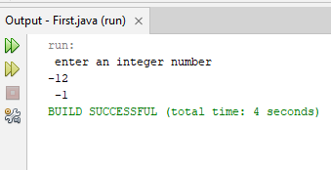

Part d:

import java.util.Scanner;
public class FirstJava
{
public static void main(String[] args)
{
Scanner input = new Scanner( System.in);

System.out.println(" enter 1st integer number ");
int num1 = input.nextInt();
System.out.println(" enter 2nd integer number ");
int num2 = input.nextInt();
System.out.println(" enter 3rd integer number ");
int num3 = input.nextInt();
int smallest;
if ( num1< num2)
if( num1 < num3)
smallest = num1;
else
smallest = num3;
else
if(num2 < num3)
smallest = num2;
else
smallest = num3;
System.out.println(" The smallest value is " + smallest);

}
}

OUTPUT:
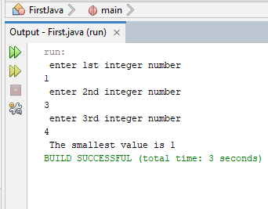

Graded task 5:

import java.util.Scanner;
public class FirstJava
{
public static void main(String[] args)
{
Scanner input = new Scanner(System.in);
System.out.println(" enter 1st integer number ");
int num1 = input.nextInt();
System.out.println(" enter 2nd integer number ");
int num2 = input.nextInt();
System.out.println(" enter 3rd integer number ");
int num3 = input.nextInt();

if ( num1 == num2 || num2 == num3 || num3 == num1)
System.out.println(" 2 ");
else if(num1 == num2 && num2 == num3 && num3 ==num1)
System.out.println(" 3 ");
else
System.out.println(" 0 “);
}

}

OUTPUT:
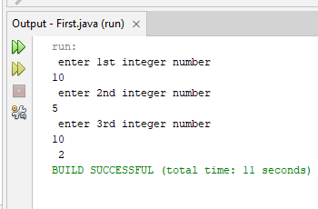

Graded lab task 6:

import java.util.Scanner;
public class FirstJava
{
public static void main(String[] args)
{
Scanner input = new Scanner( System.in);
System.out.println(" Enter a number between 1 and 10: ");
int number = input.nextInt();
switch(number)
{
case 1: System.out.println(" I ");
break;
case 2: System.out.println(" II ");
break;
case 3: System.out.println(" III ");
break;
case 4: System.out.println(" IV ");
break;
case 5: System.out.println(" V ");
break;
case 6: System.out.println(" VI ");
break;
case 7: System.out.println(" VII ");
break;
case 8: System.out.println(" VIII ");
break;
case 9: System.out.println(" IX ");
break;
case 10: System.out.println(" X ");
defalut: System.out.println(" error ");
}
}
}

OUTPUT:
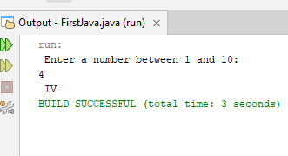

Graded task 7:

import java.util.Scanner;
public class FirstJava
{
public static void main(String[] args)
{
Scanner input = new Scanner( System.in);
System.out.println(" Enter value of length for two rectangles:");
int length1 = input.nextInt();
int length2 = input.nextInt();

System.out.println(" Enter value of width for two rectangles:");
int width1 = input.nextInt();
int width2 = input.nextInt();

int area1 = length1 * width1;
int area2 = length2 * width2;

if( area1 > area2)
System.out.println(" Area of 1st reactangle is greater");
else if ( area2 > area1)
System.out.println(" Area of 2nd reactangle is greater");
else
System.out.println(" Both areas are same ");
}
}

OUTPUT:
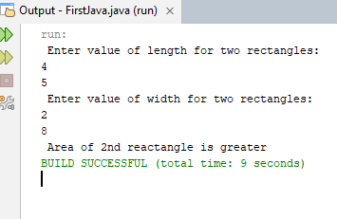

Graded lab task 8:

import java.util.Scanner;
public class FirstJava
{
public static void main(String[] args)
{
Scanner input = new Scanner( System.in);
System.out.println(" Enter a month, day and two digit year in numeric form :");
int month = input.nextInt();
int day = input.nextInt();
int year = input.nextInt();

int monthTimeDay = month * day;
if( monthTimeDay == year)
System.out.println(" The date is magic");
else
System.out.println(" The date is not a magic");

}
}
OUTPUT:
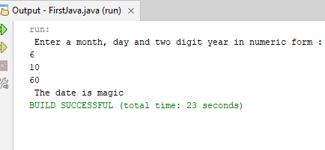

Graded task 9:

import java.util.Scanner;
public class FirstJava
{
public static void main(String[] args)
{
Scanner input = new Scanner( System.in);
System.out.println("To make one dollar,enter the number of Pennies");
int pennies = input.nextInt();
System.out.println(" Number of Nickels ");
double nickels = input.nextInt();
System.out.println(" Number of Dimes");
double dimes = input.nextInt();
System.out.println(" Number of Quarters: ");
double quarter = input.nextInt();
int dollar = 1;
pennies /= 100;
nickels/= 20;
dimes /= 10;
quarter/= 4;
double totalCoins = (int)pennies + nickels + dimes + quarter;
if( totalCoins == dollar)
System.out.println("Congratulation! you win this game");
else if( totalCoins < dollar)
System.out.println("OOPS! The coins are less than one dollar");
else
System.out.println("OOPS! The coins are more than one dollar");

}
}
OUTPUT:

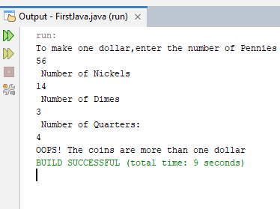

Graded Task 10:

import java.util.Scanner;
public class FirstJava
{
public static void main(String[] args)
{
Scanner input = new Scanner( System.in);
System.out.println("Enter the number of books that you purchased:");
int books = input.nextInt();
switch( books)
{
case 0: System.out.println("You earns 0 points ");
break;
case 1: System.out.println("You earns 5 points ");
break;
case 2: System.out.println("You earns 15 points ");
break;
case 3: System.out.println("You earns 30 points ");
break;
case 4: System.out.println("You earns 60 points ");

}
}
}
OUTPUT:
